**CHAPTER 11: LEADERSHIP AND COMMUNICATION**

**Leadership:** process of inspiring others to work hard to accomplish tasks

**Contemporary leadership challenges:**

* Shorter time frame to get things done
* Expectations of success to first attempt
* Complex and ambiguous problems

**Power:** ability to get someone else to do something you want done. Should be used to influence and control others for common good

**Position power:** based on manager’s official status in organization hierarchy

* **Reward power:** capability to offer something of value
* **Coercive power**: capability to punish
* **Legitimate power:** capability to give tasks because of status

**Personal power:** based on unique personal qualities that a person brings to situation

* **Expert power:** capacity to influence others because of skills and knowledge
* **Referent power:** capacity to influence others because they admire you

**Classic leadership styles:**

* **Autocratic**: work over people, keep authority within leader’s control
* **Human relations**: people over work
* **Laissez-faire:** show little concern to task, let group make decisions, don’t bother me
* **Democratic:** committed task and people, get things done, share information, help and encourage people to develop

**Fiedler’s Contingency Model:**

* Good leadership depends on a match between leadership and situational demands
* Determine leadership style: Least Preferred Co-worker Scale (LPC)
* Leadership is part of personality, hard to change
* Leadership style must fit situation
* Diagnosing situation control: quality (good, poor), degree (high, low), amount (strong, weak)
* Task oriented leaders successful in: favorable and unfavorable situations (high and low control)
* Relation-oriented leaders are successful in moderate control situations

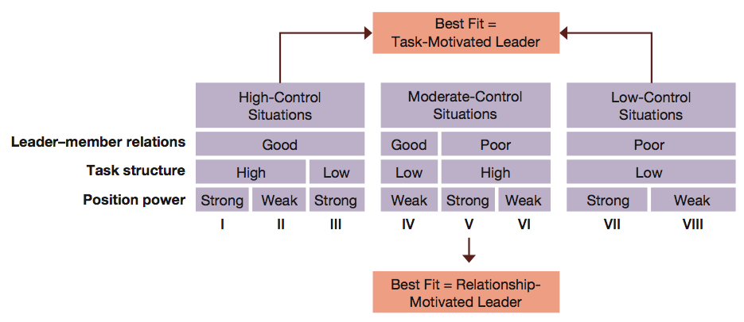

* **Transactional leadership:** directs effort of others through rewards and structures
* **Charismatic leaders:** develop relationships and inspire others
* **Transformational leadership:** truly inspirational and arouses others to work harder

**Characteristics of transformational leadership:**

* Vision
* Charisma
* Symbolism
* Empowerment
* Intellectual stimulation
* Integrity

**Emotional intelligence:** ability of people to manage themselves and their relationships effectively

* Self-awareness
* Self-regulation
* Motivation
* Empath
* Social Skills

**Drucker’s old-fashioned leadership:**

* Leadership is more than a charisma, it is hard work
* Essentials: defining mission, accept responsibility, earning and keep trust of others

**Communication:** sending and receiving symbols with messages attached to them

* Sender
* Message
* Communication channel
* Receiver
* Interpreted meaning
* Feedback

**Effective communication:** intended meaning of sender is identical to interpreted meaning of receiver

**Efficient communication:** occurs at minimum resource cost

**Communication barriers:**

* Poor choice of channels
* Poor written or oral expressions
* Failure to recognize nonverbal signs
* Physical distractions
* Status effect

**Active listening:** taking action to help someone say exactly what he or she really means

**Rules:**

* Listen for message content
* Listen for feelings
* Respond to feelings
* Note all cues
* Paraphrase and restate

**Feedback:** process of telling others how you feel about something they did

**Constructive feedback guidelines:**

* Give it directly
* Make it specific
* Give it when receiver is willing to accept it
* Make sure it’s valid
* Give it in small doses

**Low channel richness:** reports, postings, bulletins

**High channel richness:** face-to-face, meetings, videos